

Forage AIG Shields Up: Cybersecurity
As an Information Security Analyst, analyze security alerts and respond to a ransomware attack using Python and stakeholder management skills.

Task 1: Responding to a zero-day vulnerability
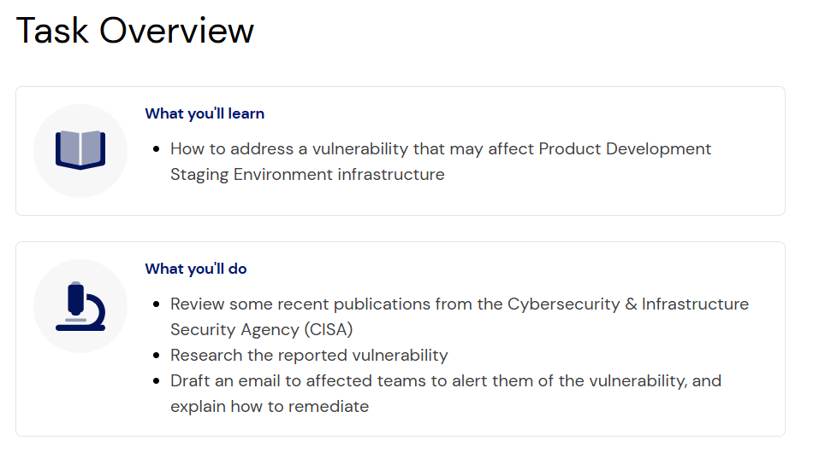
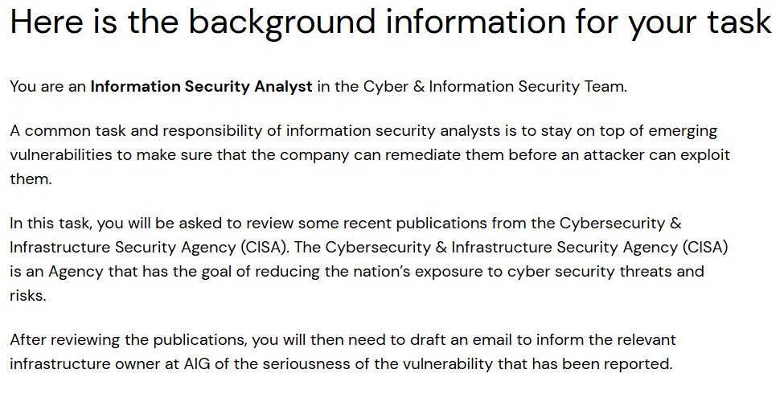
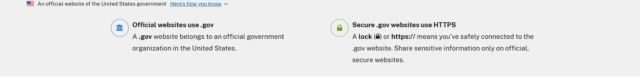

Here are the instructions for your task
The CISA has recently published the following two advisories:
- The first advisory (Log4j), outlines a serious vulnerability in one of the world’s most popular logging software.
- The second advisory explores how ransomware has been increasing and is becoming professionalized - a concern for a large company like AIG.
Your task is to respond to the Apache Log4j zero-day vulnerability that was released to the public by advising affected teams of the vulnerability.
First, conduct your research on the vulnerability using the “CISA Advisory" resources provided above as a starting point.
Next, analyze the “Infrastructure List” below to find out which infrastructure may be affected by the vulnerability, and which team has ownership.
Product Team | Product Name | Team Lead | Services Installed
IT | Workstation Management System | Jane Doe (tech@email.com) | OpenSSH  dnsmasq  lighttpd
Product Development | Product Development Staging Environment | John Doe (product@email.com) | Dovecot pop3d  Apache httpd  Log4j  Dovecot imapd  MiniServ
Marketing | Marketing Analytics Server | Joe Schmoe (marketing@email.com) | Microsoft ftpd  Indy httpd  Microsoft Windows RPC  Microsoft Windows netbios-ssn  Microsoft Windows Server 2008 R2 - 2012 microsoft ds
HR | Human Resource Information System | Joe Bloggs (hr@email.com) | OpenSSH  Apache httpd  rpcbind2-4

Draft your advisory email below
To finish this task, draft an advisory email to alert the infrastructure owner of the seriousness of this vulnerability.
For inspiration, you can use the email template provided below from our last cyber threat advisory.
From: AIG Cyber & Information Security Team
To: <affected team>
Subject: Security Advisory concerning <affected product> <affected software>
—
Body:
Hello <affected team owner>,
AIG Cyber & Information Security Team would like to inform you that a recent <affected software> vulnerability has been discovered in the security community that may affect <affected product>.
<vulnerability description>
<vulnerability risk/impact>
<vulnerability remediation>
<any assurances to ensure advisory was actioned>
For any questions or issues, don’t hesitate to reach out to us.
Kind regards,
AIG Cyber & Information Security Team
Tips for your email:
- Make it direct and straight to the point.
- You can assume the infrastructure owner is technical.
- Explain the risk/impact, method of exploitation, and remediation steps.

Advisory Email
Below is a professional advisory email tailored to the Apache Log4j (Log4Shell) vulnerability:
From: AIG Cyber & Information Security Team
To: Product Development Staging Environment
Hello John Doe,
AIG Cyber & Information Security Team would like to inform you that a critical vulnerability has been discovered in Apache Log4j, a widely used Java-based logging framework that may affect systems and applications within our environment.
The vulnerability, commonly referred to as "Log4Shell" (CVE-2021-44228), allows a remote attacker to execute arbitrary code on a vulnerable server by submitting a specially crafted log message. Exploitation can occur through various inputs that are logged by the application, including HTTP headers, form fields, chat messages, and other user-controlled data. The vulnerability requires minimal attacker interaction and can often be exploited over the internet without authentication.
Risk and Impact
Successful exploitation may allow attackers to:
- Execute arbitrary code remotely on affected systems.
- Gain unauthorized access to servers and sensitive data.
- Install malware, ransomware, or cryptomining software.
- Escalate privileges and move laterally within the network.
- Disrupt business operations and compromise system availability.
Due to the ease of exploitation and the widespread use of Log4j, this vulnerability is being actively targeted by threat actors worldwide and should be treated as a critical priority.
Required Remediation
Please take the following actions immediately:
- Identify all applications and services that use Apache Log4j.
- Upgrade Log4j to the latest secure version recommended by Apache.
- If patching cannot be completed immediately, implement temporary mitigations such as disabling JNDI lookups and removing the JndiLookup class from affected Log4j installations.
- Review firewall, IDS/IPS, and endpoint security logs for indicators of compromise or attempted exploitation.
- Conduct vulnerability scans to verify that all affected systems have been remediated.
Required Confirmation
Please provide confirmation once the following actions have been completed:
- All affected systems have been identified.
- Patches or mitigations have been successfully applied.
- Validation testing confirms systems are no longer vulnerable.
- No evidence of compromise has been detected during log reviews.
Given the severity of this vulnerability and the active exploitation observed globally, prompt remediation is essential to protect AIG systems and data.
For any questions or issues, don't hesitate to reach out to us.
Kind regards,
AIG Cyber & Information Security Team

Task 2: (Technical) Bypassing ransomware
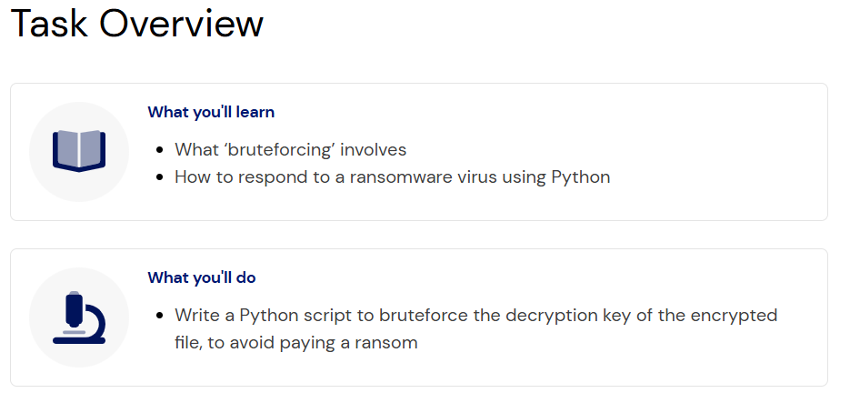

Setting the scene for your next task
Your advisory email in the last task was great. It provided context to the affected teams on what the vulnerability was, and how to remediate it.
Unfortunately, an attacker was able to exploit the vulnerability on the affected server and began installing a ransomware virus. Luckily, the Incident Detection & Response team was able to prevent the ransomware virus from completely installing, so it only managed to encrypt one zip file.
Internally, the Chief Information Security Officer does not want to pay the ransom, because there isn’t any guarantee that the decryption key will be provided or that the attackers won’t strike again in the future.
Instead, we would like you to bruteforce the decryption key. Based on the attacker’s sloppiness, we don’t expect this to be a complicated encryption key, because they used copy-pasted payloads and immediately tried to use ransomware instead of moving around laterally on the network.
